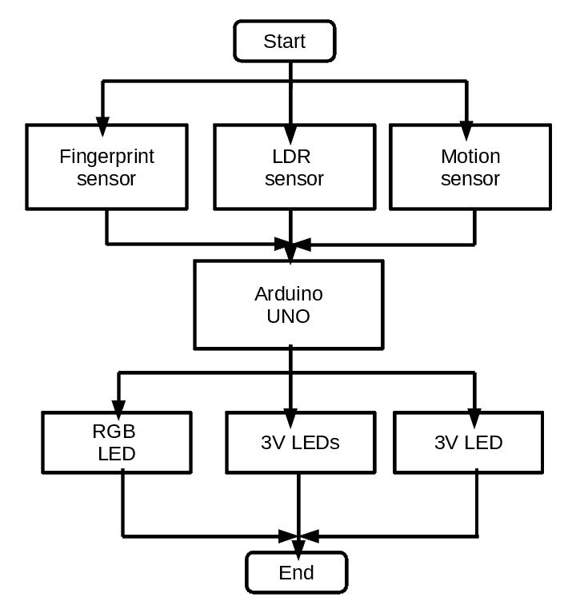

Figure 3.2 Flow Chart of Home Security with Fingerprint Sensor and

Automating LEDs around the House

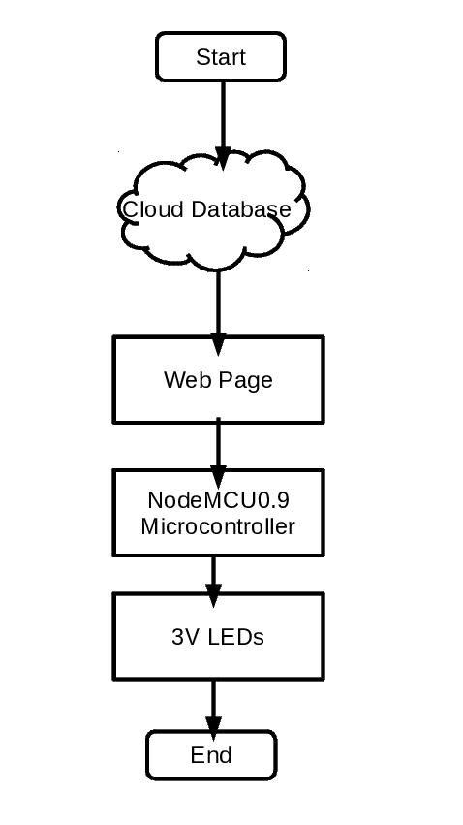

Figure 3.3 Flow Chart of Controlling LEDs in the House from the Website

**3.2. Smart Home System Procedure**

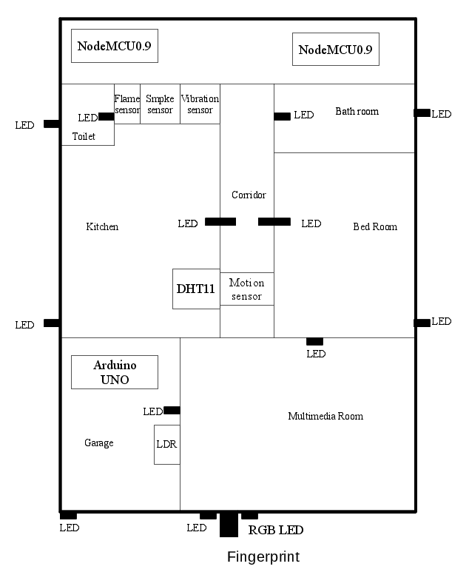

Figure 3.4 Design of the House

First of all, the fingerprint sensor detects the right finger or not and when the right finger is not detected the RGB led turns red. When the right finger is detected the RGB led will blink green and turn off. The LDR detects the condition of the light intensity around the house and if the day is so cloudy or becomes darker, the LEDs around the house will turn on automatically. The motion sensor detects the corridor in the house and if it detects movement, the corresponding led will turn on till the movement is not detected.

And then in the kitchen, the smoke sensor detects the smoke. If the smoke is detected the buzzer will alarm and the node MCU will send the message (i.e. the smoke is detected) to the cloud databasethat is connected to the web page *lktsmarthome.000webhostapp.com*.

The flame sensor detects the flame. If the flame is detected the buzzer will alarm and then sending the message to the cloud that the flame is detected. Temperature sensor reads the temperature inside the room.

When the temperature value changes compared to the previous value, the node MCU will send this value to the cloud database. The vibration sensor detects the vibration. If the vibration is detected the buzzer will alarm and then sending the message to the cloud that the vibration is detected.

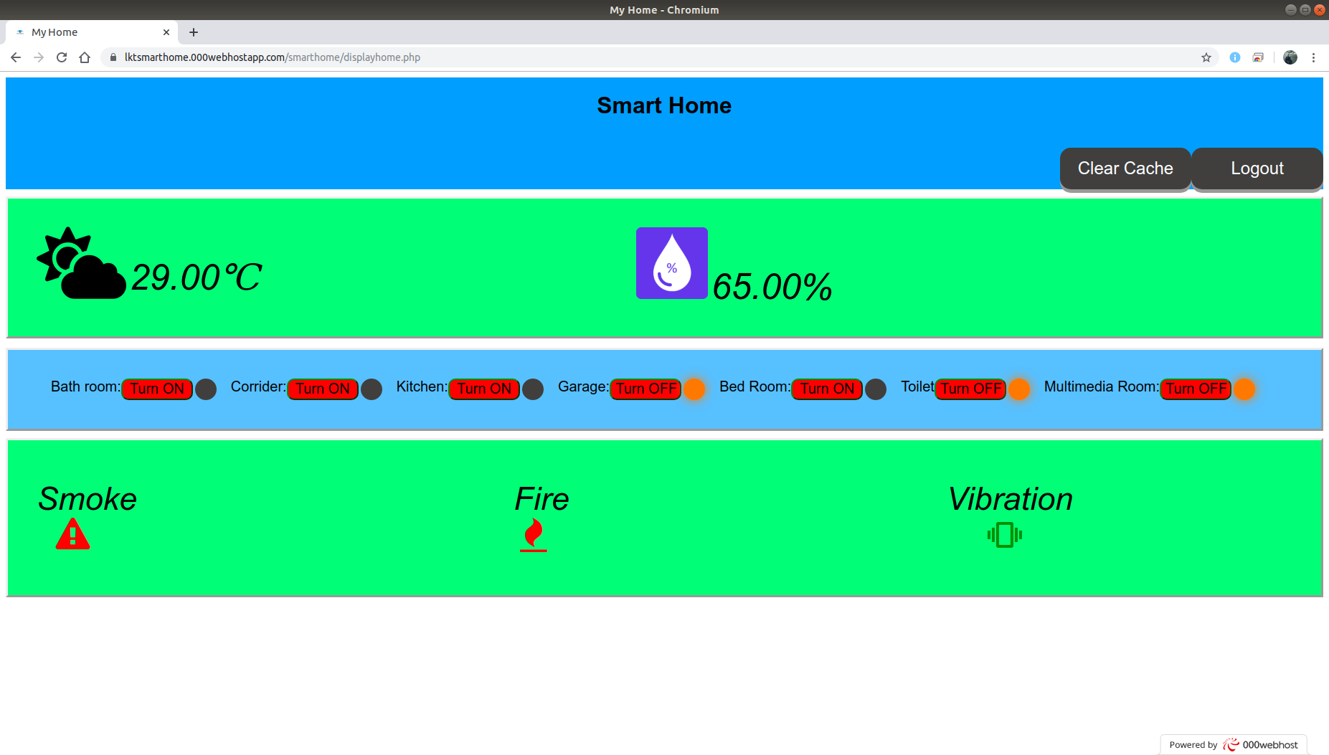

Figure 3.5 Website View

As the fig. 3.5the last temperature value sent from the NodeMCU is 29°C and the humidity is 65%. The red warning sign shows the smoke is detected, the flame is also detected and the vibration is not.

The LEDs, inside the house can be controlled from this website by the button from fig. 3.5when the button is pressed it will change the status in the database of this LED which has pressed. And the NodeMCU sends a HTTP request to the webpage that the status of the LEDs in the database will be generated as JSONformat in fig. 3.6 below. In fig. 3.5 the Garage, Toilet, Multimedia Room are glowing yellow and it means these LEDs are turned on. And the rest of the LEDs are turned off.

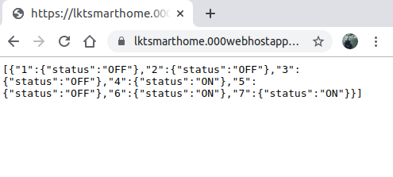

Figure 3.6 The Webpage that is Generated Data from the Cloud Database of the LEDs Status in JSON Format

**3.3. Circuit Designs of the Project**

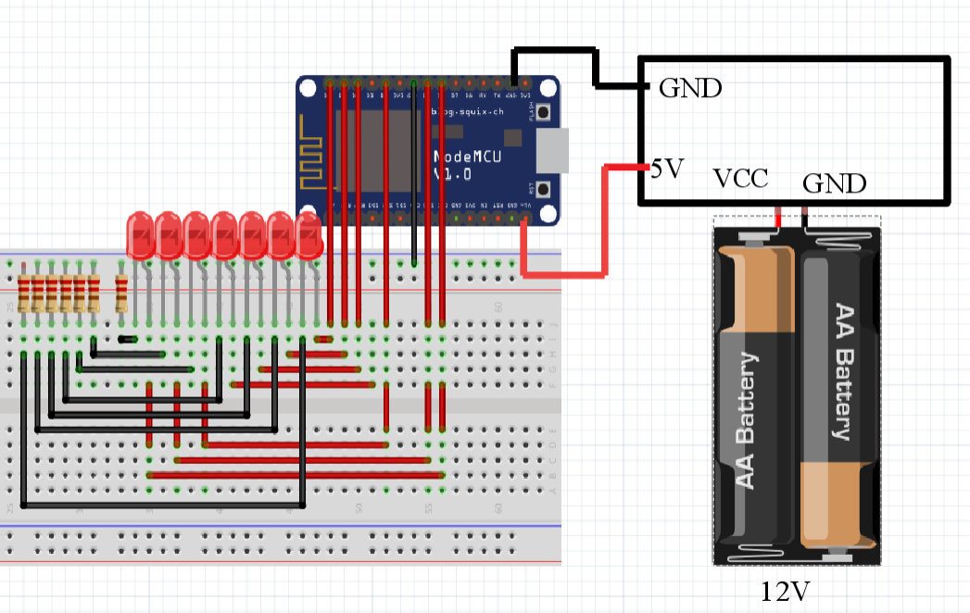

Figure 3.7 Circuit Diagram of Controlling LEDs in the House from the Website

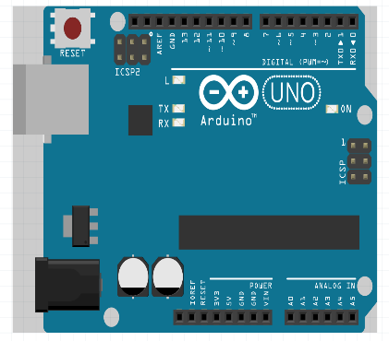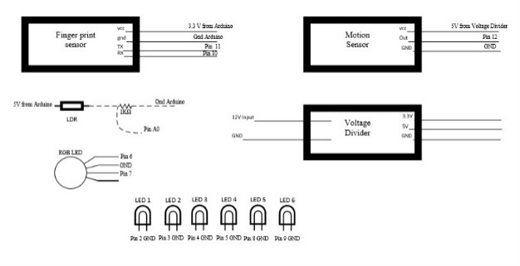

Figure 3.8 Circuit Diagram of Home Security with Fingerprint Sensor and Automating LEDs around the House

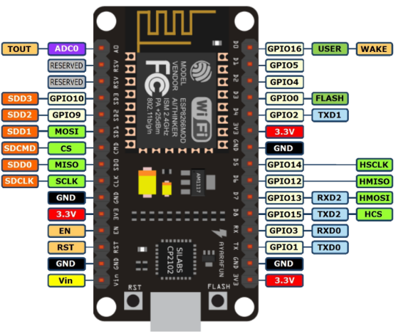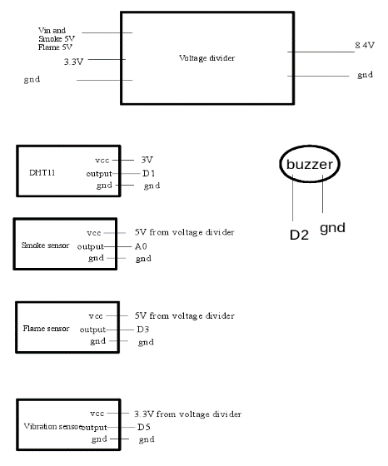

Figure 3.9 Circuit Diagram Reading Sensor Values and Upload it on Cloud